Functional splice factor analysis
Aim: Understanding the functional link between splice factors identified to be differentially regulated.
Steps:
- Make a heatmap with SFs, from the Rogaslka et al., 2024, using their gene expression values after perturbation of U2AF2, U2AF1, and SF1 individually.
- Note. Please do step 1 with different k-means clustering values to identify clusters revealing the underlying patterns. Such as SFs regulated in all, or only under specific conditions such as U2AF2 & U2AF1, U2AF1 & SF1, U2AF2 unique, etc.
- The supplement table 1 includes the categories the SFs belong to. It would be interesting to label that in the heatmap. So we know whether the SFs from certain groups are clustered together.
- Select your favorite clusters based on the underlying patterns. Write it down clearly why you selected those clusters.
- For these splice factors, identify,
  - Their Correlation value with the splice factor pair by referring to the supplement table 9. For example, if the splice factor in red is your favorite, then the tg column indicates the SF pair it might be linked to, and the cor column indicates their correlation based on the similarities in AS changes following their perturbation.
so | tg | cor | absCor
SNRPD3 | SNRPD2 | 0.80267565 | 0.80267565
XAB2 | CWC22 | 0.80071131 | 0.80071131
SF3A3 | SF3A1 | 0.79493646 | 0.79493646
SNRPF | SNRPD2 | 0.78349882 | 0.78349882
  - Simpley take s9 and filter for your favorite splice factors
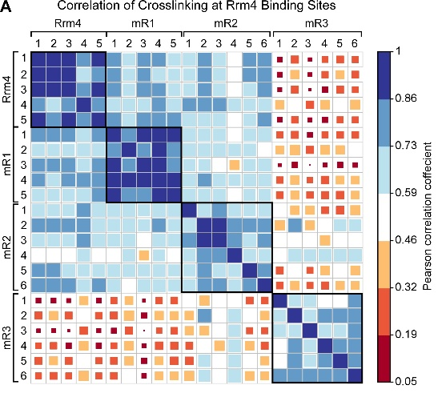
- Using the table from Step 5, make a correlation dot plot. Something like this. Unlike this your plot will compare each splice factor and their correlation with its pair. Add labels or groupings on the dot plot by SF category (from Step 3).

There is a next page

- You can also make a correlation heatmap like we do in the DESeq2 analysis to understand functionally relevant splice factors. This might give us an idea about the regulatory changes in splicing regulation after these splice factors. For example, are there splice factors, such as SM proteins or U2 snRNA factors are upregulated upon these perturbations?

